* **Lab Task 6**

Write a SQL statement that uses a subquery to display the airport name and established year of every airport that is in the same country as the airport 'Jinnah Intl'.

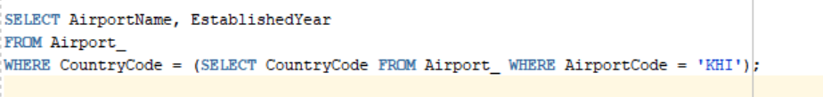

OUTPUT:

